Nombre--------------------------------------------------------------------------------------------------curso------------------fecha-------------------------------------------
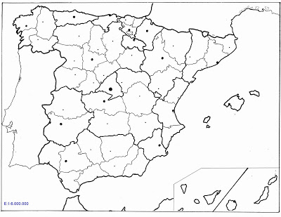
LEYENDA
- COMUNIDAD AUTÓNOMA
- CAPITAL COMUNIDAD AUTONOMA
- Provincias
- Capital de Provincia (si es deferente)

